
Sukkur IBA University
Department of Computer Science
ESE-201: Digital Logic Design Lab

Lab # 05: Comparator
Instructor: Muhammad Ismail Qureshi
Submission Profile
Name: Ghulam Mustafa Submission date 25/12/2025
CMS ID: 023-24-0513 Marks obtained:
Comments: Receiving authority name and signature:

________________________________________________________________________________
Instructor Signature

Note: Submit this lab hand-out on LMS/e-learning before the next lab with attached solved activities and exercises.
Lab Learning Objectives:

Upon successful completion of this experiment, the student will be able:
- To implement and verify Comparator operations using 74LS85 IC & NI ELVIS Kit

Lab Hardware and Software Required:
- 74LS85IC (Comparator)
- NI ELVIS Kit
- Breadboard
- Connecting Wires

Background Theory:

Comparator:
Comparator is a combinational logic circuit that compares two input binary numbers and signals if the two numbers are equal, or if one is higher than the other. The basic function of comparator is to compare the magnitude of two quantities to determine the relationship of those quantities. A binary comparator usually has three outputs: A=B, A>B and A<B. A 1-bit comparator compares two 1-bits (A & B) and determines whether they are “greater than” or “less than” or “equal to” each other by a high level on the appropriate output. As the outputs exclusively depend on the temporary inputs, the circuit is composed by logic gates. The logic symbol and logic diagram for 1-bit comparator as shown in Fig 5.1 (a & b).

Fig 5.1: (a) Logic Symbol (b) Logic symbol for 1-bit Comparator
74LS85 Comparator IC:
The TTL 74LS85 IC is a four bit magnitude comparator which will perform comparison of two 4-bit binary numbers. The pin configuration of IC is shown in Fig 5.2. This IC consists of eight comparing inputs (A0, A1, A2, A3, B0, B1, B2, B3), three cascading inputs $(I_{A}<B, I_{A}=B,$and${ I}_{A}>B)$. This device compares two 4-bit words (A & B) and determines whether they are “greater than”,” less than” or “equal to” each other by a high level on the appropriate output. For words greater than 4-bits, units can be cascaded by connecting the outputs $(O_{A}<B,O_{A}=B,$ and $O_{A}>B)$ of the least significant stage to the cascaded inputs $(I_{A}<B, I_{A}=B,$and${ I}_{A}>B)$ of the next significant stage. In addition the least significant stage must have a high level (VIN (1)) applied to the A=B input and low level voltage (VIN (0)) applied to A>B and A<B inputs.
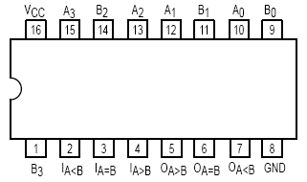
Fig 5.2: 74LS85 Magnitude Comparator IC pin configuration
Lab Examples:
Implementation of 1-bit Comparator:
- Carry out the pin configuration of 74LS85 IC
- Take 74LS85 IC and insert it in the breadboard present on the NI ELVIS-II kit
- Apply power supply to it
- Connect inputs A and B to the data switches SW0 and SW1 respectively
- Connect the three output to the LEDs
- Analyse the circuit behaviour by carrying out different combinations with the data switches and fill the observation table for comparator
Table 5.1: Observation table of 1-bit Comparator
Input |  | Output (A>B) |  | Output (A=B) |  | Output (A<B)
A | B | LED  (on / off) | Level  ( 1 / 0 ) | LED  (on / off) | Level  ( 1 / 0 ) | LED  (on / off) | Level  ( 1 / 0 )
0 | 0 | off | O | On | 1 | Off | O
0 | 1 | Off | O | Off | O | On | 1
1 | 0 | On | 1 | Off | O | Off | O
1 | 1 | Off | O | On | 1 | Off | O

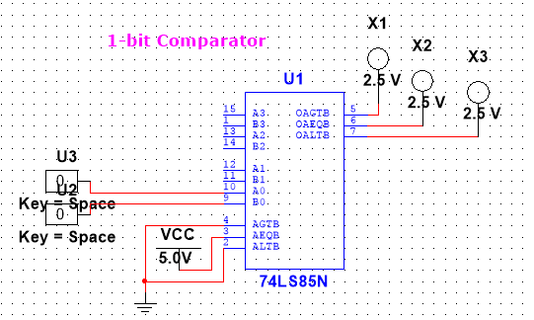
Lab Activities:

Implementation of 4-bit comparator using 74LS85:
- Connect the inputs related to binary numbers A to four switches and the inputs related to input B to other four switches
- Connect inputs I_{A<B}, I_{A=B}, I_{A>B} to ground
- Connect outputs O_{A<B}, O_{A=B}, O_{A>B} to three LEDs.
- With the switches compose all combinations between A & B and verify the comparator operations
Table 5.2: Observation table of 4-bit Comparator
Input |  |  |  |  |  |  |  | Output
4-bit Word A |  |  |  | 4-bit Word B |  |  |  | (A>B) | (A=B) | (A<B)
A0 | A1 | A2 | A3 | B0 | B1 | B2 | B3 | LED  (on / off) | LED  (on / off) | LED  (on / off)
0 | 0 | 0 | 0 | 1 | 1 | 1 | 1 | Off | Off | on
0 | 0 | 0 | 1 | 1 | 1 | 1 | 0 | Off | Off | on
0 | 0 | 1 | 0 | 1 | 1 | 0 | 1 | Off | Off | on
0 | 0 | 1 | 1 | 1 | 1 | 0 | 0 | Off | On | Off
0 | 1 | 0 | 0 | 1 | 0 | 1 | 1 | Off | Off | On
0 | 1 | 0 | 1 | 1 | 0 | 1 | 0 | Off | On | Off
0 | 1 | 1 | 0 | 1 | 0 | 0 | 1 | Off | On | Off
0 | 1 | 1 | 1 | 1 | 0 | 0 | 0 | On | Off | Off
1 | 0 | 0 | 0 | 0 | 1 | 1 | 1 | Off | Off | On
1 | 0 | 0 | 1 | 0 | 1 | 1 | 0 | Off | On | On
1 | 0 | 1 | 0 | 0 | 1 | 0 | 1 | Off | On | On
1 | 0 | 1 | 1 | 0 | 1 | 0 | 0 | On | Off | Off
1 | 1 | 0 | 0 | 0 | 0 | 1 | 1 | Off | On | Off
1 | 1 | 0 | 1 | 0 | 0 | 1 | 0 | On | Off | Off
1 | 1 | 1 | 0 | 0 | 0 | 0 | 1 | On | Off | Off
1 | 1 | 1 | 1 | 0 | 0 | 0 | 0 | On | Off | Off

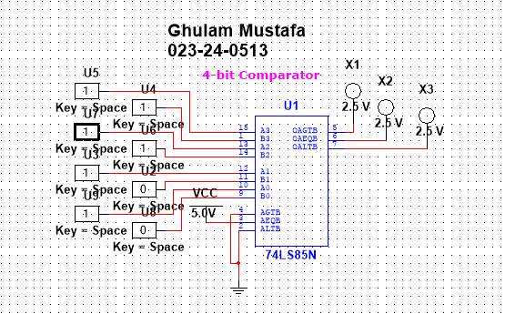
Lab Exercises:

Design and Implementation of 8-bit comparator using 74LS85:
Description:

- An 8-bit comparator is a digital circuit used to compare two 8-bit binary numbers and determine whether one number is greater than, less than, or equal to the other.
The 74LS85 is a 4-bit magnitude comparator. To compare 8-bit numbers, two 74LS85 ICs are cascaded.
One IC compares the lower 4 bits
The second IC compares the upper 4 bits
The output of the lower-bit comparator is connected to the cascade inputs of the upper-bit comparator. Based on this, the circuit gives three outputs:
A > B
A < B
A = B
This circuit is commonly used in digital systems and processors where number comparison is required.

Schematic Diagram:
